Flowchart

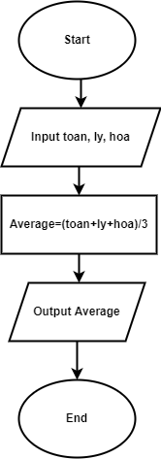

Pseudo-code

Begin

Input toan, ly, hoa

Average = (toan+ly+hoa)/3

Output Average

End